1)

%macro print 2

mov eax,sys_out

mov ebx,stdout

mov ecx,%1

mov edx,%2

int 80h

%endmacro

%macro input 2

mov eax,sys_in

mov ebx,stdin

mov ecx,%1

mov edx,%2

int 80h

%endmacro

section .bss

num1 resb 9

num2 resb 9

result resb 9

section .data

sys_out equ 4 ;To output

sys_in equ 3 ;To Input

stdout equ 1 ;Stdout

stdin equ 2 ;Stdins

p1 db 'ENTER THE FIRST NUMBER: '

p1L equ $-p1

p2 db 'ENTER THE SECOND NUMBER: '

p2L equ $-p2

p3 db 'ADD = '

p3L equ $-p3

section .text

global _start:

_start:

print p1,p1L

input num1,9

print p2,p2L

input num2,9

mov esi,3 ;Pointing to the rightmost digit

mov ecx,4 ;Number of digits

clc

add_loop:

mov al,[num1+esi]

adc al,[num2+esi] ;adc add with carry

aaa ;Adjust after addition

pushf

or al,30h

popf

mov [result+esi],al

dec esi ;decrement

loop add_loop

print p3,p3L

print result,9

mov eax,1

mov ebx,0

int 80h

OUTPUT

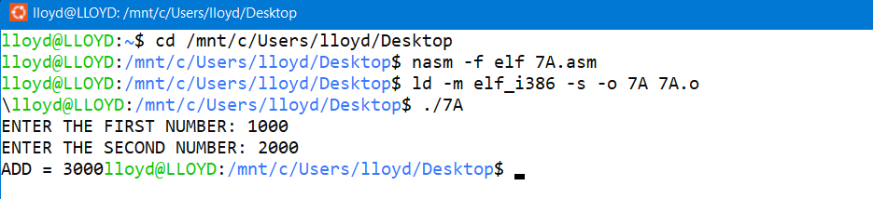

2)

%macro print 2

mov eax,sys_out

mov ebx,stdout

mov ecx,%1

mov edx,%2

int 80h

%endmacro

%macro input 2

mov eax,sys_in

mov ebx,stdin

mov ecx,%1

mov edx,%2

int 80h

%endmacro

section .bss

num1 resb 9

num2 resb 9

result resb 9

section .data

sys_out equ 4 ;To output

sys_in equ 3 ;To Input

stdout equ 1 ;Stdout

stdin equ 2 ;Stdins

p1 db 'ENTER THE FIRST NUMBER: '

p1L equ $-p1

p2 db 'ENTER THE SECOND NUMBER: '

p2L equ $-p2

p3 db 'SUB= '

p3L equ $-p3

section .text

global _start:

_start:

print p1,p1L

input num1,9

print p2,p2L

input num2,9

mov esi,3 ;pointing to the rightmost digit

mov ecx,4 ;Number of digits

clc

sub_loop:

mov al,[num1+esi]

sbb al,[num2+esi] ;substract with borrow

aas ;Adjust after substraction

pushf

or al,30h

popf

mov [result+esi],al

dec esi ;decrement

loop sub_loop

print p3,p3L

print result,9

mov eax,1

mov ebx,0

int 80h

OUTPUT

